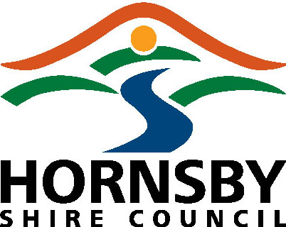 PAYMENT ADVICE

An application will be AUTOMATICALLY cancelled if payment is not received within SEVEN (7) WORKING DAYS of issue of a Payment Advice

PAYMENT REFERENCE: 1087093

APPLICATION NUMBER: PP/2/2022

PROPERTY DETAILS: 679-681 Old Northern Road, DURAL NSW 2158 - Lot 3 DP 395437

APPLICANT DETAILS:

Keylan Consulting Pty Ltd
Suite 2, Level 1
1 Rialto Lane
MANLY NSW 2095

APPLICATION FEES:

$63,550.00

Methods of Payment
Internet Payments via Credit Card  MasterCard and Visa Only  BPAY is currently not available for applications payments  Council will offer American Express as a payment option along with Visa and Mastercard from 1 July 2020. Please note a surcharge will apply to all credit card transactions from 1 July 2020 as per Council’s Fees and Charges 21-22 i.e. 0.50%. | Log onto Council’s website www.hornsby.nsw.gov.au  Select   Select ‘Application Receipt’  Select ‘Outstanding’  Enter ‘Payment Reference’ - 1087093  Select  and follow the prompts to complete payment

